Computational Private Information Retrieval in Blockchain
Integrating Computational PIR with Blockchain: Design, Implementation and Application
Exploring Computational PIR for query confidentiality in Hyperledger Fabric
Hiding query from endorsing peers using Computational PIR in Hyperledger Fabric
Artur Iasenovets
Address of Author (University’s Research Institution or School) Chongqing 400065

Abstract 2
1. Introduction 4
1.1 Background and Motivation 4
1.2 Research Gap in related work 5
1.3 Objectives and Contributions 6
1.4 Paper Organization 6
2. Preliminaries 6
2.1 Fabric native privacy techniques 7
2.2 Private information retrieval basics 7
3. CPIR-enabled retrieval workflow 8
3.1 Stage 1: Ledger initialization 8
3.2 Stage 2: Metadata discovery 9
3.3 Stage 3: Private information retrieval 10
3.4 Stage 4. Local decryption and reconstruction 12
4. Performance analysis 14
4.1 Implementation 14
4.2 Performance metrics 14
4.3 Observed results 15
4.3.1 Encryption latency 16
4.3.2 Decryption latency 17
4.3.3 Query Size (KB) 18
4.3.4 Evaluation Latency 19
4.3.1 End-To-End Latency 20
4.4 Comparative analysis 21
4.5 Limitations 22
5. Conclusion 22
6. References 22

Abstract
Permissioned blockchains ensure integrity of writes but leave reads visible to endorsing peers. We present a computational private information retrieval (CPIR) design integrated into Hyperledger Fabric chaincode that hides query indices from endorsers during evaluate operations. Our approach encodes the ledger’s key–value table as a plaintext polynomial and evaluates encrypted selection vectors homomorphically, returning only an encrypted result to the client. We construct the BGV scheme using primitives from Lattigo library and measure client encryption/decryption, peer-side evaluation, ciphertext size, and end-to-end latency. Results show practical performance (e.g., XX–YY ms end-to-end for N=…, logN=…, single multiplication) while eliminating index leakage otherwise exposed in baseline GetState calls. We discuss how CPIR complements Fabric’s Private Data Collections (PDC) and Fabric Private Chaincode (FPC), outline residual leakages (size/timing), and release a runnable artifact for reproducibility.
Keywords: Computational PIR, Hyperledger Fabric, Query Privacy, Homomorphic Encryption.

Introduction

Background and Motivation
Blockchains are widely adopted for tamper-evident, auditable data management across multiple organizations. Their guarantees, however, primarily cover writes. In Hyperledger Fabric, the separation of evaluate and submit makes the read/privacy gap explicit:
- Evaluate: a read-only proposal is sent to one or more endorsing peers, which execute the chaincode simulatively and return results. No block is created and no writes are committed.
- Submit: endorsements are collected, then the orderer sequences the transaction into a block, and all peers validate and apply the write-set to the world state.
Crucially, evaluate calls—though never recorded on-chain—expose function arguments and read-sets to endorsing peers running the chaincode. Thus, in consortium settings, the dominant read-privacy risk is exposure to peer operators, not to the ledger.
To make this concrete, Figure 1 contrasts two audit records emitted by our chaincode. A baseline PublicQueryWithAudit("record012") explicitly reveals the queried key to endorsers. In contrast, PIRQueryWithAudit(encQueryB64) logs only an opaque Base64-encoded selector; no human-readable index appears. Avoiding per-key GetState(index) and instead evaluating over an oblivious plaintext representation of the database prevents the RW-set or chaincode logs from revealing query intent.
This motivates the use of Private Information Retrieval (PIR). PIR protocol [1] enables a client to retrieve data from a database without revealing which item was requested. Earlier Information-Theoretic (IT-PIR) schemes [1], [2], [3], [4], [5] required multiple non-colluding servers, which is ill-suited to consortium blockchain settings where endorsing peers may collude. Computational PIR (CPIR) schemes [6], [7], [8], [9], [10], [11], [12], [13], [14], [15], [16], based on homomorphic encryption, avoids this by allowing a single endorser to process an encrypted query. Model the database as a vector $D=\{d_{0}​,d_{1}​,…,d_{n-1}​\}$. To retrieve $d_{i}$ privately, the client forms a one-hot selection vector $v_{i}$​ defined as $v_{i}​=(0,…,0,1,0,…,0)$ where the position of the "1" corresponds to the desired record at index $i$, encrypts it as $c_{q}​={Enc}_{pk}​(v_{i}​)$ and the peer computes $c_{r}=c_{q}​⋅D={Enc}_{pk}​(d_{i}​)$, returning $c_{r}$​, for client decryption $d_{i}={Dec}_{sk}​(c_{r}​)$, obtaining the desired database entry $d_{i}$ without exposing index $i$.
Combining Fabric with CPIR yields a dual guarantee: (1) writes remain auditable and attributable; (2) reads become unlinkable to specific keys—even to endorsing peers.
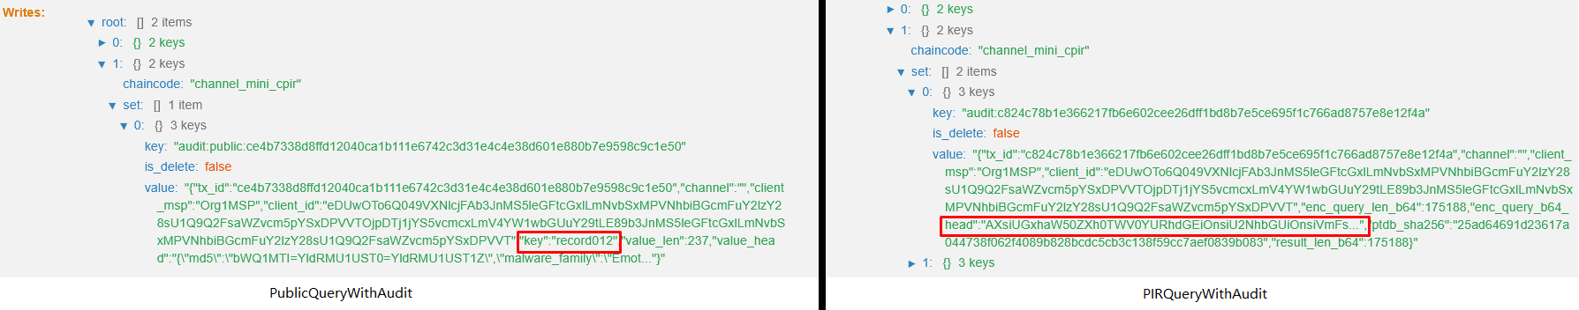
Figure 1. What endorsing peers “see” in audit records. Left: baseline PublicQueryWithAudit exposes the exact key (record012). Right: CPIR-based PIRQueryWithAudit exposes only an opaque encrypted selector (EncQueryB64), hiding the queried index.

Research Gap in related work
Despite the rapid growth of blockchain privacy research, PIR-enabled blockchain frameworks remain underexplored. Prior work in blockchain-based data sharing has focused on Sybil-resilient frameworks [17], differential disclosure [18], non-attributable tokenized exchange [19], or access-controlled smart contracts [20]. These efforts ensure anonymity or selective sharing, but they do not hide query access patterns. Meanwhile, the use of HE and PIR in applied domains is emerging but limited: off-chain FHE analytics [21], vehicular PIR for LBS [22], blockchain-integrated PIR with ZKPs [23], PIR over IPFS [24], and OT-based PIR in Fabric [25] [26]. These approaches show feasibility, but none provide a systematic framework for embedding computational PIR directly into smart contracts of a permissioned blockchain.
This gap persists partly due to a misconception: blockchain and PIR have been seen as serving unrelated functions—immutability vs. confidentiality—when in fact they are complementary across the full lifecycle of data sharing. Writes should be transparent, auditable, and attributable, but reads should remain private, particularly in multi-organizational ledgers where peer operators may be semi-trusted.

Objectives and Contributions
We study query privacy for Fabric reads and argue that CPIR can be integrated natively in chaincode to hide indices from endorsers. We consider four observers: (1) same-org peer operator; (2) other-org peer; (3) orderer; (4) external network observer. Our goal is to hide the queried index and access pattern at least from (1), ideally also from (2), while preserving ledger auditability.
Our contributions are fivefold:
- CPIR-on-Fabric design. A chaincode/SDK design that evaluates encrypted selection vectors over a plaintext, polynomialized view of the ledger’s key–value table (BGV via Lattigo), returning only an encrypted result.
- Evaluate-phase privacy demonstration. A side-by-side audit view (baseline vs CPIR) showing exactly what endorsers learn before/after CPIR, and a discussion of residual side channels (size/timing/frequency) and mitigations.
- Empirical evidence. Microbenchmarks of client-side encryption/decryption, peer-side evaluation, ciphertext size, and end-to-end latency across representative parameter sets (single ct×pt multiply).
- Open-Source Release. To encourage reproducibility and use by other researchers, we open-source the complete CPIR-on-Blockchain system, including chaincode, client, and experimental setup. The repository is available at:

Paper Organization
The rest of the paper is organized as follows: Section 2 introduces the cryptographic and blockchain preliminaries. Section 3 reviews related work on blockchain privacy and PIR applications. Section 4 details our methodology, including the multi-channel architecture, encoding strategy, and CPIR workflow. Section 5 presents our implementation, performance analysis and compares it with the related work. Section 6 concludes the paper.

Preliminaries
In this section, we introduce necessary background knowledge for a reader to understand the problem of private CTI sharing using CPIR: CTI standardized formats, PIR and BGV scheme basics for CPIR implementation, slot-packing strategy and permissioned blockchain capabilities for CTI sharing.

Fabric native privacy techniques
Hyperledger Fabric separates roles: endorsing peers (execute chaincode and see arguments), committing peers (validate and update state), and the ordering service (consensus). The administrators of endorsing peers are the natural adversaries for read privacy: they can inspect chaincode input parameters, logs, and proposal payloads. Hiding reads therefore means hiding query intent from endorsers—either cryptographically (CPIR) or by moving execution into a Trusted Execution Environment (TEE). We hereby acknowledge several native solutions for privacy that Hyperledger Fabric provides:
Separate channels. Fabric’s multi-channel architecture has been leveraged for privacy partitioning and scalability in IoV and enterprise contexts [27] [28], including defenses against malicious peer coordination [29]. However, multi-channel isolation controls who can see which ledger, not how queries inside a channel leak intent. We adapt multi-channel for other purpose.
Private Data Collections (PDC). PDCs [30] restrict which organizations see plaintext values. The channel ledger stores hashes of private keys/values, while collection members hold the plaintext in their private state. PDCs solve access control, but do not hide reads from the endorsing peers inside the collection: the endorsers still see the function arguments and can infer access patterns. PDCs are complementary to CPIR (limit who can see data) but do not replace CPIR (hide what you read).
Fabric Private Chaincode (FPC). FPC [31], [32] executes chaincode inside Intel SGX enclaves on peers, encrypting state and arguments so that even peer operators cannot inspect them. FPC significantly reduces operator-side leakage but introduces (TEE) trust/attestation assumptions and hardware constraints.

Private information retrieval basics
Lattice-based homomorphic encryption schemes, such as Brakerski/ Fan-Vercauteren (BFV), Brakerski-Gentry-Vaikuntanathan (BGV), and CKKS [33], [34], [35] have emerged as foundational technologies for practical CPIR implementations. For example, SealPIR [36] is based on Fan-Vercauteren FHE cryptosystem (FV) [33] to homomorphically evaluate encrypted queries against plaintext databases. Similarly, our approach utilizes the BGV scheme, providing efficient plaintext polynomial operations necessary for embedding complex JSON-structured records into a numeric representation suitable for homomorphic operations.
To address the research gap mentioned Section 1, we base our CPIR implementation on lattice-based BGV cryptographic schemes which is built on computational hardness assumptions of Learning With Errors (LWE) and Ring Learning With Errors (RLWE) [37], [38]. BGV scheme operates over two polynomial rings:
- Ciphertext Ring ($R_{q}$):
$$R_{q}=Z_{q}\left[X\right]/X^{N}+ 1$$
where:
- $Z_{q}$: Integers modulo $q$, the ciphertext modulus.
- $X^{N}+ 1$: The polynomial defining the quotient ring structure.
- $N=2^{\log{N}}$: The polynomial (ring) degree where N is some power of 2, (e.g., N=8192 for log N = 13), it also sets the number of SIMD slots available for data packing.
- Plaintext Ring ($R_{t}$):
$$R_{t}=Z_{t}[X]/X^{N}+ 1$$
where:
- $Z_{t}$: Integers modulo the plaintext modulus $t$, chosen as $t=65537$.
Thus, every plaintext message is represented as a polynomial $m(X)∈R_{t}$​, and every ciphertext as an element in $R_{q}^{k}$​, where $k≥2$ is the ciphertext size (two polynomials in the BGV case).

CPIR-enabled retrieval workflow
We demonstrate 4 workflow stages of our CPIR-enabled CTI retrieval in Hyperledger Fabric in Sections 4.3.1-4.3.4. Totally, there are 2 clients from organisations A and B, chaincode and ledger components, such as Ledger Initialization, Metadata Discovery, Private Information Retrieval and Local Decryption and Reconstruction.

Stage 1: Ledger initialization
The ledger initialization stage in the CPIR-enabled CTI retrieval workflow, as depicted in Figure 4.3.X, orchestrates the setup of a homomorphically encoded database within the Hyperledger Fabric ledger. This process begins when a client invokes the InitLedger(n, maxJsonLength, channel) function, specifying the number of records (n), the maximum JSON record length (maxJsonLength), and the target channel. Based on the channel, the chaincode dynamically selects the cryptographic parameters through createParams(), setting the ring dimension $N=2^{\log{N}}$ (where $\log{N}∈\{13,14,15\}$), ciphertext modulus $\log{Q}=\left[54\right]$, and plaintext modulus $T=65537$. Next, generateRecords() synthesizes CTI records in JSON format, each constrained to maxJsonLength bytes. The procedure then computes the slot allocation per record via calcSlotsPerRec(), using $\text{slotsPerRecord}=\left\lceil \frac{\max_{i}\left|{\text{JSON}}_{i}\right|}{8}\right\rceil ×8$ ensuring byte-aligned mapping into BGV slots. The system validates packing feasibility through validateRingCapacity(), verifying that $requiredSlots=n⋅slotsPerRecord≤N$ otherwise, the initialization request is rejected. For each record, packRecordsLoop() embeds its byte representation into a contiguous slot window within the polynomial plaintext $m_{DB}​(X)=\sum_{i=0}^{N-1}{d_{i}}X^{i}$ where each coefficient $d_{i}∈[0,255]$. Finally, the packed polynomial is encoded and stored on the ledger as PTDB, forming the cryptographically structured database state for subsequent PIR queries.

Figure 4.3.X: Ledger Initialization stage
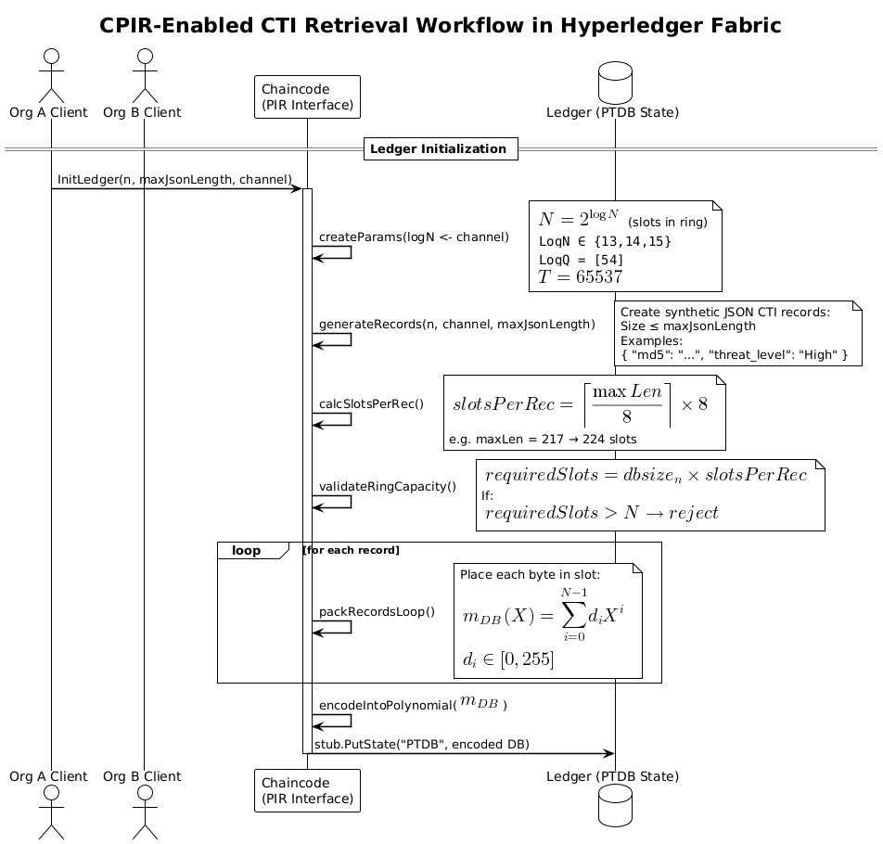

Stage 2: Metadata discovery
During the metadata discovery stage illustrated in Figure 4.3.X., clients obtain essential structural information about the encrypted database stored on the Hyperledger Fabric ledger. After ledger initialization, a client invokes two chaincode functions sequentially. First, publicQueryALL() retrieves the total number of CTI records by accessing the state variable "PTDB" through the Fabric stub API (stub.GetState("PTDB")). The chaincode responds with totalRecords = n, which is critical for constructing a selection vector of appropriate length during PIR query formation. Subsequently, the client calls getSlotsPerRecord(), which returns the precomputed packing parameter slotsPerRecord = s by reading "slotsPerRecord" from the ledger state. This parameter determines how many BGV slots are allocated to encode each JSON CTI record in the plaintext polynomial database. Metadata parameters n and s serve as the foundation for building the homomorphic selection vector $m_{q}​\left(X\right)$ and validating that the PIR request aligns with ledger packing constraints.
Figure 4.3.X: Metadata Discovery stage
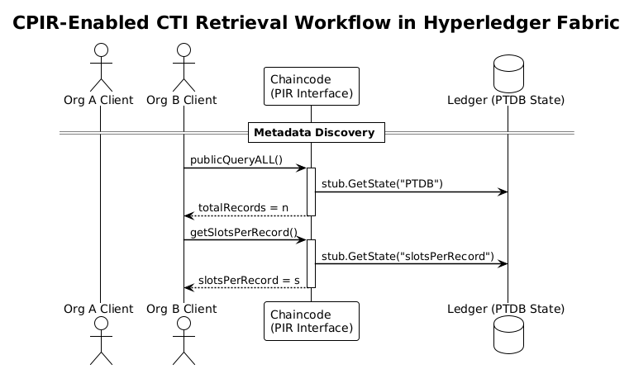
By separating metadata retrieval from full PIR evaluation, this stage ensures that query generation remains lightweight and deterministic while preserving database confidentiality.

Stage 3: Private information retrieval
Private information retrieval stage consists of two steps, as shown in Figure 4.3.3.
Step 1: Client-Side Query Encoding and Encryption. To initiate a PIR request, the client must construct a selection vector indicating the desired record and encrypt it under the BGV scheme. Suppose the client wishes to retrieve record $i∈\{0,1,…,n-1\}$, where n is the total number of records, and each record occupies $s∈N$ slots in the plaintext polynomial.
The client constructs a binary selection vector $v∈\{0,1\}$of length $N$, such that:
$$v=\{\begin{matrix}1 if j∈\{i⋅s,i⋅s+1,…,i⋅s+s-1 \\ 0 otherwise\end{matrix}\}$$
This means that only the slots corresponding to record i are marked with 1s; all others remain 0. The selection vector v is then encoded into a plaintext polynomial $m_{q}(X)∈R_{t}$ using the BGV encoder, where each coefficient stores one entry of v.
$$m_{q}\left(X\right)=v_{0}​+v_{1}​X+v_{2}​X^{2}+⋯+v_{N-1}X^{N-1}$$
As you might have already noticed, the plaintext database polynomial and the selection vector are encoded using the same strategy:
$$m_{q}​\left(X\right)=\sum_{i=0}^{N-1}{v_{i}}X^{i}=v_{0}​+v_{1}​X+v_{2}​X^{2}+⋯+v_{N-1}X^{N-1}$$
The polynomial $m_{q}\left(X\right)$ is encrypted with the recipient's public key $pk$ to produce a ciphertext:
$${ct}_{q}={Enc}_{pk}(m_{q})∈R_{q}^{2}$$
which is then Base64-encoded and sent to the blockchain node.
Step 2. Server-Side Homomorphic Evaluation. Upon receiving the encrypted query c, the server evaluates it homomorphically against the plaintext database PTDB. The PTDB is itself a plaintext polynomial where the entire CTI dataset is linearly packed $m_{DB}​\left(X\right)∈R_{t}, m_{DB}​\left(X\right)= \left[{rec}_{0}\left|{rec}_{1}\right|…{rec}_{n-1}\right]$, such that each record occupies a contiguous window of s coefficients.
The PIR evaluation consists of a single homomorphic multiplication operation:
$${ct}_{r}=Eval({ct}_{q}⋅m_{DB})=Enc(v⋅m_{DB}​)$$
Because the encrypted selector vector contains zeros outside the targeted slot range, multiplication isolates the desired record under encryption, leaving other coefficients masked to zero. Resulting ciphertext ${ct}_{r}∈R_{q}^{2}$​ contains an encrypted version of the queried record and is returned to the client after Base64-encoding.

Figure 4.3.X: Private information retrieval stage
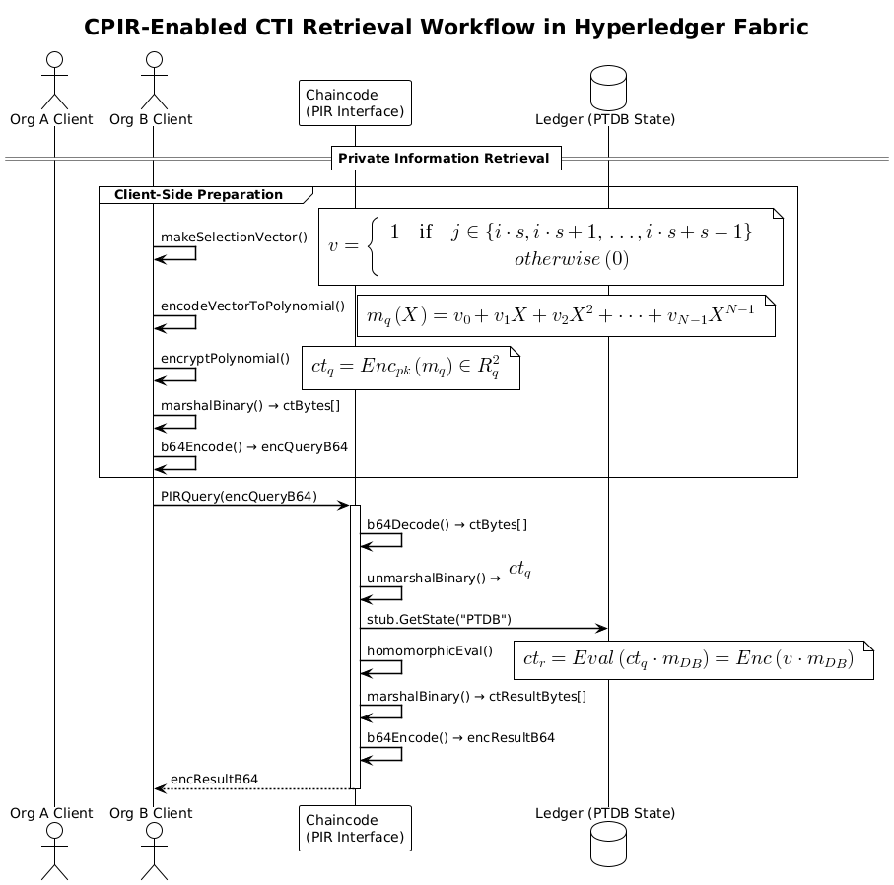

Stage 4. Local decryption and reconstruction
Finally, last stage process is depicted in Figure 4.3.X. After receiving the encrypted response ${ct}_{r}$, the client decrypts it using their secret key $sk$, producing the plaintext polynomial $m'(X)={Dec}_{sk}\left({ct}_{r}\right)∈R_{t}$ This polynomial contains zero values in all slots except those corresponding to the queried record i.
The client determines the slot interval with non-zero coefficients:
$$j∈[i⋅s,(i+1)⋅s-1)$$
Let $u∈Z_{T}^{s}$ ​ be the slice of coefficients from the interval above:
$$u=({m^{'}}_{i⋅s}​,{m^{'}}_{i⋅s+1}​,…,{m^{'}}_{\left(i+1\right)⋅s-1}​)​$$
Each coefficient $(m_{j}^{'​})∈[0,255]⊂Z_{t}$ represents one byte of the JSON string for the record. The vector u is decoded back into a byte array and interpreted as a UTF-8 JSON string representing the original CTI record:
$${record}_{i}​=UTF8Decode(u)$$
If the record occupies fewer than s bytes, padding zeros are automatically stripped during reconstruction.
Figure 4.3.X: Local decryption and reconstruction stage
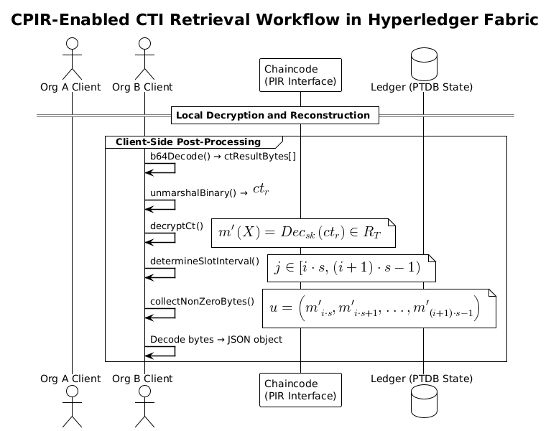

Performance analysis
In this section, we discuss the practical execution of our proposed system. We start with the implementation details in “Implementation” section followed by the performance metrics’ description in “Performance metrics” section. We discuss and analyze the observed results in “Observed results” section. Furthermore, we compare our system’s performance with the state-of-the-art models in “Comparative analysis” section. Finally, we also notify some challenges faced in our system in “Limitations” section.

Implementation
To achieve this, we use lattice-based Brakerski-Gentry-Vaikuntanathan (BGV) homomorphic encryption scheme and its primitives from an open-source Go cryptographic library “Lattigo” [39], such as key generation, encryption, encoding and decoding of polynomials, and evaluator to base our CPIR implementation upon.
We implement in a three-organizational consortium blockchain environment in Hyperledger Fabric. Setting up a three-organization consortium blockchain with Hyperledger Fabric involves defining the network configuration, setting up chain code, configuring organizations, deploying the network, interacting with the network using SDKs, and monitoring the network’s health and performance. The steps for implementation are as follows.

Performance metrics
The performance metrics of our system are split into two groups, such as Cryptosystem metrics and Hyperledger Caliper benchmarks, as show in Table 5.2.X. Cryptosystem metrics include encryption, evaluation and decryption latency, full end-to-end cycle latency, query size and noise budget growth.
Table 5.2.X. Quality Metrics
Metric | Test Level | Description | How Measured or Calculated | Where collected
Cryptosystem Metrics
Encryption Latency (ms) | Unit / micro-bench | Time to generate a single PIR query ciphertext on the client. | time.EncryptQueryBase64 around a tight loop. | Off-chain (client)
Query Size (KB) | Unit | Size of Base-64 query payload sent to the server. | len(encQueryB64)/1024. | Off-chain (client)
Eval Latency (ms) | Integration | Time that chaincode spends in pirQuery (cipher × plain multiplication). | Wall-clock inside chaincode or time.Since() in Go CC; return as custom metrics field. | Off-chain (client)
Decryption Latency (ms) | Unit | Time to decrypt and decode PIR result on the client. | DecryptResult with time.Since(). | Off-chain (client)
End-To-End Cycle (enc, eval, dec) (ms)
Noise Budget (bits) | Unit / analytical | Remaining noise after one evaluation. | rlwe.Noise(params, sk, ct) (client side) or GetRLWENoise() if added to CC. | Off-chain preferred (client decrypts), optional on-chain if exposed.
Hyperledger Caliper benchmarks
Server Throughput (QPS) | Load / system | PIR requests handled per second by a peer under load. | External load-gen (wrk, hey) ÷ total elapsed. | Hybrid: load runner off-chain, execution inside CC.
Ledger Footprint (MB) | System / storage | Disk space used by PTDB + JSON world-state. | Host filesystem du -sh <leveldb/ledgers> . | On-peer, measured externally (shell on peer container).
CPU Utilization (%) | Load / system | Average CPU load of peer during PIR burst. | docker stats or pprof sampling. | On-peer, collected externally.
Memory Peak (MB) | Load / system | Peak RAM of peer while handling PIR. | docker stats --no-stream, parse RSS peak. | On-peer, collected externally.
Scalability Factor (Δt/ΔN) | Analytical | Slope of Eval-latency vs. database size (Nrec). | Linear regression of latency samples for N = 10…1000. | Hybrid: latency gathered (on- or off-chain), regression off-chain.

Observed results
In sections 5.3.1-5.3.4 we will show off-chain cryptosystem metrics, such as encryption, evaluation, decryption and end-to-end cycle latency for 3 distinct logN values (13-15) as well as noise budget growth. For each logN value, we will iterate over every feasible slotsPerRecords and numRecords. Selection process of feasible configurations is explained in the Experimental matrix in Section 4. In sections 5.3.5-5.3.X we will run an on-chain Hyperledger Caliper benchmarks set.

Encryption latency
This section examines the client-side encryption latency during PIR query construction as a function of two application-level parameters, database size (numRecords) and packing granularity (slotsPerRecord) under three cryptographic configurations defined by logN ∈ {13, 14, 15}, corresponding to ring dimensions N=8192, 16384, and 32768 slots, respectively.
The results summarized in Figure 5.3.X indicate that encryption latency for PIR query construction is dominated by the ring dimension (logN), while variations in database size (dbSize) have no significant effect despite variations in numRecords. Each curve corresponds to a fixed logN value (13, 14, 15), and the x-axis represents the number of CTI records, ranging from 16 to 128. However, when scaling logN from 13 → 14 → 15, the latency increases superlinearly at each step $6.1514 ms​→ 9.8232 ms→30.6055 ms$.
Figure 5.3.X: Client Encryption Latency vs Database Size
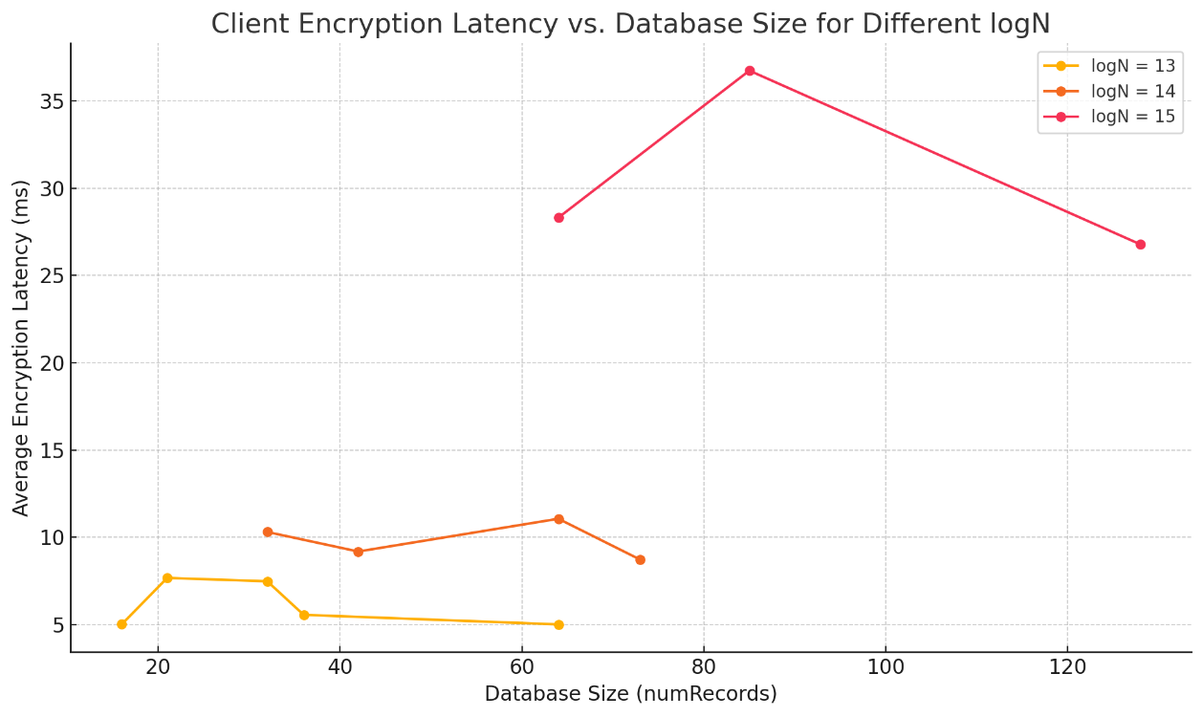
Similarly, the Figure 5.3.X illustrates that variation in slotsPerRecord also shows no significant effect on encryption latency for any fixed logN. While slotsPerRecord determines how many consecutive slots are set to 1 in the query vector (and thus how many slots are "active"), the BGV scheme encrypts the entire vector of size N, regardless of how many slots are non-zero. Each curve corresponds to a fixed logN value (13, 14, 15), and the x-axis represents the number of slots allocated to a single CTI record, ranging from 128 to 512.
Figure 5.3.X: Client Encryption Latency vs SlotsPerRecord

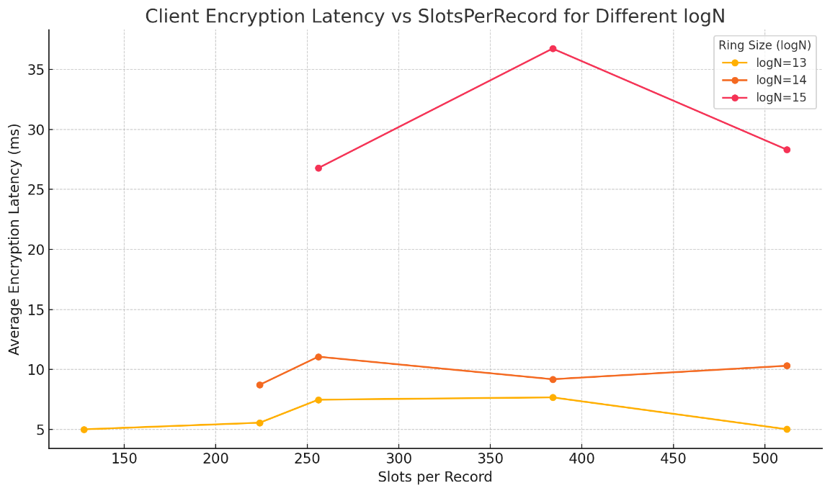
Figures 5.3.X(a) and 5.3.X(b) confirm that encryption latency is insensitive to query density and depends almost exclusively on the chosen ring size. While slotsPerRecord controls how many consecutive slots correspond to a record, the BGV encoder packs and encrypts the entire polynomial of size N in every query.

Decryption latency
Figure 5.3.X shows that client-side decryption latency is primarily influenced by the ring dimension parameter logN, and not by the database size (numRecords). As logN increases from 13 to 15, latency rises significantly—due to the growth in ring size $N=2^{\log{N}}$, which directly affects the cost of polynomial operations during decryption. This is expected, as BGV decryption complexity scales with O(N log N).
In contrast, varying the number of records in the database has negligible effect. This is because PIR responses are single ciphertexts containing all slots; decryption always processes the full vector, regardless of how many slots contain actual data.
Figure 5.3.X: Client Decryption Latency vs Database Size
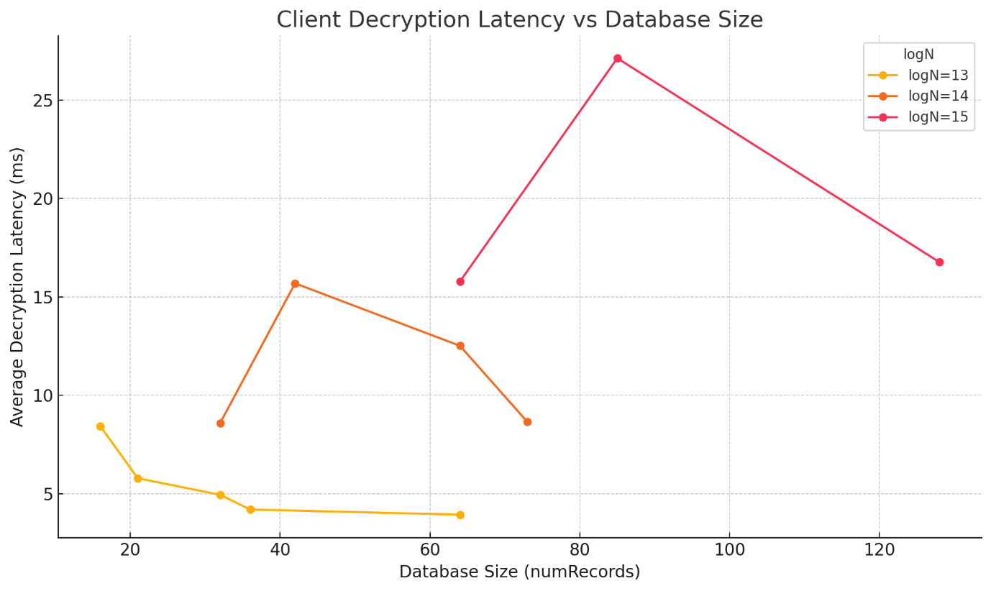
These results highlight a key trade-off: larger logN enables more records but increases client-side computation, while smaller rings reduce latency but limit capacity. Efficient system design must balance these factors based on expected database size and latency requirements
Figure 5.3.X: Client Decryption Latency vs SlotsPerRecord
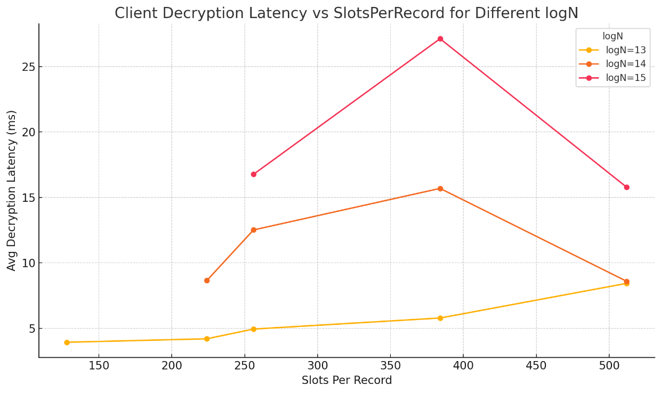

Query Size (KB)
Figure 5.3.X illustrates the relationship between the BGV ring parameter logN and the size of the PIR query (in kilobytes). Each data point corresponds to the average query size measured over 30 epochs at fixed settings for dbSize, slotsPerRecord, and target index. The x-axis denotes the logarithmic ring dimension logN, which defines the total number of plaintext slots as $N=2^{\log{N}}$. The y-axis shows the Base64-encoded ciphertext size of a single query in kilobytes.
Figure 5.3.X: Query Size vs LogN
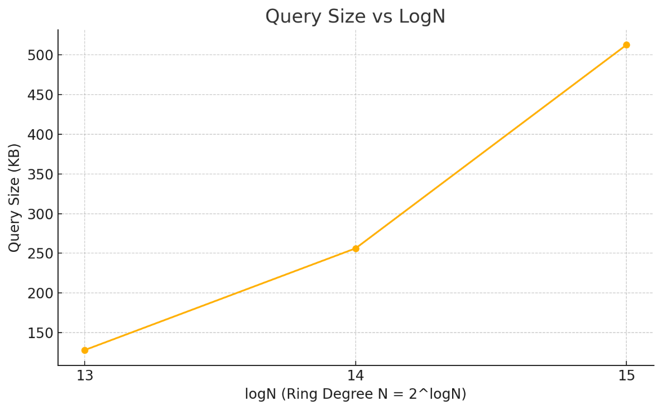
We observe that the query size scales linearly with the ring dimension: for logN = 13, the size is approximately 128 KB; for logN=14, it doubles to 256 KB; and for logN=15, it reaches 512 KB. Notably, other factors such as dbSize and slotsPerRecord (maxJsonLength) have no observable impact on ciphertext size. This knowledge allows the system designer to predict query bandwidth usage solely based on cryptographic parameters, and to budget network resources accordingly.

Evaluation Latency
Fig. X illustrates the latency distribution for PIR queries across different parameter sets, including ring dimension (logN), database size, and slots allocated per record. The number of slots per record grows proportionally with the maximum JSON record length, influencing packing efficiency and evaluation cost. We observe that configurations with higher slotsPerRecord (e.g., 512 slots) result in increased latency variance due to sparse packing, while configurations closer to optimal packing (128–256 slots) achieve lower and more consistent query times. This confirms that slots-per-record tuning is critical for achieving efficient SIMD encoding in the BGV scheme, as excessive padding increases multiplicative overhead without improving throughput.
Figure 5.3.X: PIR Evaluation Latency
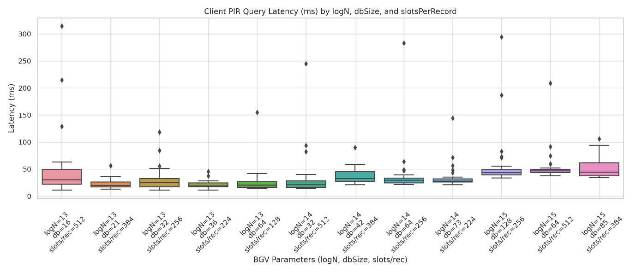

End-To-End Latency
To assess the practical efficiency of our BGV-based PIR system, we measured the end-to-end latency of client queries across multiple configurations varying in ring dimension (logN), database size, and record length. Each query involves three phases: encryption (client-side key switching and ciphertext generation), evaluation (homomorphic multiplication on the server), and decryption (client-side decoding). Figure X presents the average latency decomposition across 30 epochs per configuration.
Figure 5.3.X: End-to-End PIR Latency
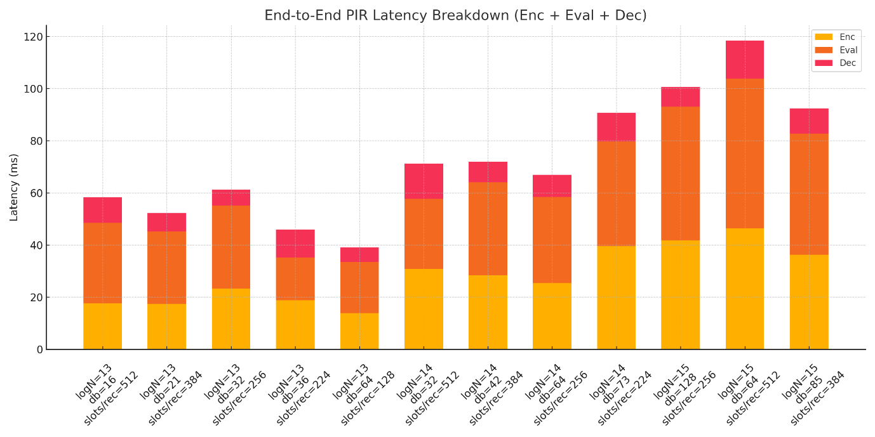
Results indicate that evaluation dominates total cost, accounting for 60–80% of the end-to-end time, especially at higher logN values where ciphertext size and plaintext packing depth increase computational complexity. Encryption remains relatively lightweight, scaling modestly with ring size, while decryption contributes minimally (<10 ms) due to efficient SIMD decoding. Notably, configurations with slotsPerRecord ≥ 512 introduce additional overhead in both encryption and evaluation, as the packed polynomial becomes denser. Overall, our architecture achieves query completion times below 150 ms for the largest configuration tested, demonstrating practical feasibility for privacy-preserving CTI retrieval in consortium blockchain environments.

Comparative analysis
Our system is the first to apply CPIR for private CTI sharing on a blockchain. Unlike prior works that rely on access control, anonymity tokens, differential sharing or IT-PIR, our approach ensures query privacy while preserving full data utility and robustness against collusion threat model. For comparative analysis, we selected key works on privacy in CTI sharing, including Gong & Lee [50], Dunnett et al. [51], Huff et al. [11], Allouche et al. [52], BRON [62], and DEBPIR [64]. Table 5.4.X. summarizes their privacy techniques, use of multi-channel architecture, and support for variable-length multi-slot encoding.
Table 5.4.X. Experiment parameter groups (settings)
Reference | Privacy Methods | Multi-Channel Architecture | Variable-Length Multi-Slot Encoding
Gong & Lee – BLOCIS [17] | None (Access validation only) | ✗ | ✗
Dunnett et al. [18] | Differential Privacy | ✗ | ✗
Huff et al. [19] | Token-based anonymity | ✗ | ✗
Allouche et al. – TRADE [20] | Access Control via Smart Contracts | ✗ | ✗
Kumar et al. – BRON [23] | IT-PIR + ZKP | ✗ | ✗
Kumar et al. - DEBPIR [25] | IT-PIR (OT-based) | ✗ | ✗
Our Work (CPIR-Enabled CTI Sharing) | CPIR (HE-based) | ✓ | ✓

Our approach differs from prior CTI sharing frameworks in three key ways. First, we employ CPIR with homomorphic encryption, removing the need for multiple non-colluding servers common in IT-PIR schemes. Second, we introduce adaptive multi-slot encoding, enabling complete JSON-based CTI objects to fit within a single ciphertext for efficient retrieval—unlike earlier methods that assume fixed-size or scalar records. Third, by leveraging multi-channel architecture mapped to cryptosystem parameters, we achieve scalability and performance isolation not addressed in previous works. These contributions together provide strong query privacy with practical efficiency for collaborative CTI sharing.

Limitations
Despite its benefits, our system inherits limitations common to homomorphic encryption and blockchain technologies. First, computational overhead remains significant compared to plaintext queries, especially for large ciphertexts or complex packing strategies, though our adaptive multi-slot encoding mitigates this by reducing the number of ciphertexts per query. Second, storage and ledger growth can challenge scalability in long-running CTI networks, necessitating pruning strategies or off-chain storage for historical data. Third, key management and trust assumptions in CPIR-based frameworks require careful governance to prevent misuse or key compromise. Finally, post-quantum resilience remains an open challenge for lattice-based schemes like BGV, which underpins our implementation. While parameter selection provides some security margin, migration to NIST-standardized post-quantum HE primitives will be a necessary future enhancement.

Conclusion
This paper presents the first CPIR-enabled blockchain framework for private CTI sharing, combining computational PIR with adaptive multi-slot encoding and multi-channel architecture for performance scalability. Unlike existing solutions based on access control, anonymity tokens, or IT-PIR, our approach guarantees query confidentiality without compromising data utility or collusion resistance. By mapping Fabric channels to cryptosystem parameters, we achieve performance isolation across heterogeneous CTI datasets, while our encoding strategy enables efficient retrieval of variable-length JSON records in a single PIR response. Experimental evaluation demonstrates the practicality of our design, achieving privacy-preserving retrieval with acceptable latency across multiple parameter configurations.
In future work, we aim to integrate zero-knowledge proofs for query integrity, self-sovereign identity for participant authentication, and post-quantum secure HE schemes to enhance robustness against emerging threats. Overall, our system lays the groundwork for trust-preserving CTI collaboration, encouraging broader adoption of decentralized intelligence sharing in critical sectors.

References
[1] B. Chor, E. Kushilevitz, O. Goldreich, and M. Sudan, “Private information retrieval,” J ACM, vol. 45, no. 6, pp. 965–981, Nov. 1998, doi: 10.1145/293347.293350.
[2] A. Beimel, Y. Ishai, E. Kushilevitz, and J.-F. Raymond, “Breaking the O(n1/(2k-1)) Barrier for Information-Theoretic Private Information Retrieval,” in Proceedings of the 43rd Symposium on Foundations of Computer Science, in FOCS ’02. USA: IEEE Computer Society, Nov. 2002, pp. 261–270.
[3] D. Demmler, A. Herzberg, and T. Schneider, “RAID-PIR: Practical Multi-Server PIR,” in Proceedings of the 6th edition of the ACM Workshop on Cloud Computing Security, in CCSW ’14. New York, NY, USA: Association for Computing Machinery, Nov. 2014, pp. 45–56. doi: 10.1145/2664168.2664181.
[4] C. Devet, I. Goldberg, and N. Heninger, “Optimally Robust Private Information Retrieval,” in 21st USENIX Security Symposium (USENIX Security 12), Bellevue, WA: USENIX Association, Aug. 2012, pp. 269–283. [Online]. Available: https://www.usenix.org/conference/usenixsecurity12/technical-sessions/presentation/devet
[5] I. Goldberg, “Improving the Robustness of Private Information Retrieval,” in 2007 IEEE Symposium on Security and Privacy (SP ’07), May 2007, pp. 131–148. doi: 10.1109/SP.2007.23.
[6] C. Aguilar-Melchor, J. Barrier, L. Fousse, and M.-O. Killijian, “XPIR : Private Information Retrieval for Everyone,” Proc. Priv. Enhancing Technol., 2016, Accessed: July 24, 2025. [Online]. Available: https://petsymposium.org/popets/2016/popets-2016-0010.php
[7] Z. Brakerski and V. Vaikuntanathan, “Efficient Fully Homomorphic Encryption from (Standard) LWE,” in 2011 IEEE 52nd Annual Symposium on Foundations of Computer Science, Oct. 2011, pp. 97–106. doi: 10.1109/FOCS.2011.12.
[8] C. Cachin, S. Micali, and M. Stadler, “Computationally Private Information Retrieval with Polylogarithmic Communication,” in Advances in Cryptology — EUROCRYPT ’99, J. Stern, Ed., Berlin, Heidelberg: Springer, 1999, pp. 402–414. doi: 10.1007/3-540-48910-X_28.
[9] Y.-C. Chang, “Single Database Private Information Retrieval with Logarithmic Communication,” in Information Security and Privacy, H. Wang, J. Pieprzyk, and V. Varadharajan, Eds., Berlin, Heidelberg: Springer, 2004, pp. 50–61. doi: 10.1007/978-3-540-27800-9_5.
[10] C. Dong and L. Chen, “A Fast Single Server Private Information Retrieval Protocol with Low Communication Cost,” in Computer Security - ESORICS 2014, M. Kutyłowski and J. Vaidya, Eds., Cham: Springer International Publishing, 2014, pp. 380–399. doi: 10.1007/978-3-319-11203-9_22.
[11] C. Gentry and Z. Ramzan, “Single-Database Private Information Retrieval with Constant Communication Rate,” in Automata, Languages and Programming, L. Caires, G. F. Italiano, L. Monteiro, C. Palamidessi, and M. Yung, Eds., Berlin, Heidelberg: Springer, 2005, pp. 803–815. doi: 10.1007/11523468_65.
[12] A. Kiayias, N. Leonardos, H. Lipmaa, K. Pavlyk, and Q. Tang, “Optimal Rate Private Information Retrieval from Homomorphic Encryption,” Proc. Priv. Enhancing Technol., vol. 2015, no. 2, pp. 222–243, June 2015, doi: 10.1515/popets-2015-0016.
[13] E. Kushilevitz and R. Ostrovsky, “Replication is not needed: single database, computationally-private information retrieval,” in Proceedings 38th Annual Symposium on Foundations of Computer Science, Oct. 1997, pp. 364–373. doi: 10.1109/SFCS.1997.646125.
[14] H. Lipmaa, “First CPIR Protocol with Data-Dependent Computation,” in Information, Security and Cryptology – ICISC 2009, Springer, Berlin, Heidelberg, 2010, pp. 193–210. doi: 10.1007/978-3-642-14423-3_14.
[15] H. Lipmaa and K. Pavlyk, “A Simpler Rate-Optimal CPIR Protocol”.
[16] X. Yi, M. G. Kaosar, R. Paulet, and E. Bertino, “Single-Database Private Information Retrieval from Fully Homomorphic Encryption,” IEEE Trans. Knowl. Data Eng., vol. 25, no. 5, pp. 1125–1134, May 2013, doi: 10.1109/TKDE.2012.90.
[17] S. Gong and C. Lee, “BLOCIS: Blockchain-Based Cyber Threat Intelligence Sharing Framework for Sybil-Resistance,” Electronics, vol. 9, no. 3, Art. no. 3, Mar. 2020, doi: 10.3390/electronics9030521.
[18] K. Dunnett, S. Pal, G. D. Putra, Z. Jadidi, and R. Jurdak, “A Trusted, Verifiable and Differential Cyber Threat Intelligence Sharing Framework using Blockchain,” in 2022 IEEE International Conference on Trust, Security and Privacy in Computing and Communications (TrustCom), Dec. 2022, pp. 1107–1114. doi: 10.1109/TrustCom56396.2022.00152.
[19] P. Huff and Q. Li, “A Distributed Ledger for Non-attributable Cyber Threat Intelligence Exchange,” presented at the Security and Privacy in Communication Networks. 17th EAI International Conference, SecureComm 2021, Virtual Event, September 6–9, 2021, Proceedings, Part I, Nov. 2021. Accessed: July 18, 2025. [Online]. Available: https://eudl.eu/doi/10.1007/978-3-030-90019-9_9
[20] Y. Allouche, N. Tapas, F. Longo, A. Shabtai, and Y. Wolfsthal, “TRADE: TRusted Anonymous Data Exchange: Threat Sharing Using Blockchain Technology,” Mar. 24, 2021, arXiv: arXiv:2103.13158. doi: 10.48550/arXiv.2103.13158.
[21] J. J. Sustronk, “Analysing Cyber Threat Intelligence Data Using Fully Homomorphic Encryption”, Accessed: July 21, 2025. [Online]. Available: https://essay.utwente.nl/93355/1/Sustronk_MA_EEMCS.pdf
[22] Z. Tan, C. Wang, M. Zhou, and L. Zhang, “Private information retrieval in vehicular location-based services,” in IEEE World Forum on Internet of Things, WF-IoT 2018 - Proceedings, Institute of Electrical and Electronics Engineers Inc., May 2018, pp. 56–61. doi: 10.1109/WF-IoT.2018.8355189.
[23] G. Kumar, R. Saha, M. Gupta, and T. H. Kim, “BRON: A blockchained framework for privacy information retrieval in human resource management,” Heliyon, vol. 10, no. 13, p. e33393, June 2024, doi: 10.1016/j.heliyon.2024.e33393.
[24] M. Mazmudar, S. Veitch, and R. A. Mahdavi, “Peer2PIR: Private Queries for IPFS,” Nov. 26, 2024, arXiv: arXiv:2405.17307. doi: 10.48550/arXiv.2405.17307.
[25] G. Kumar, R. Saha, M. Conti, and T. H. Kim, “DEBPIR: enhancing information privacy in decentralized business modeling,” Complex Intell. Syst., vol. 11, no. 7, p. 290, May 2025, doi: 10.1007/s40747-025-01868-y.
[26] “Oblivious transfer,” Wikipedia. May 26, 2025. Accessed: July 21, 2025. [Online]. Available: https://en.wikipedia.org/w/index.php?title=Oblivious_transfer&oldid=1292423635
[27] Y. Liu, Y. Feng, and K. Sakurai, “Hyperledger Fabric-Based Multi-Channel Structure for Data Exchange in Internet of Vehicles,” Electronics, vol. 14, no. 3, 2025, doi: 10.3390/electronics14030572.
[28] P. Thakkar, S. Nathan, and B. Viswanathan, “Performance Benchmarking and Optimizing Hyperledger Fabric Blockchain Platform,” in 2018 IEEE 26th International Symposium on Modeling, Analysis, and Simulation of Computer and Telecommunication Systems (MASCOTS), Sept. 2018, pp. 264–276. doi: 10.1109/MASCOTS.2018.00034.
[29] O. Wu et al., “An optimal scheduling algorithm considering the transactions worst-case delay for multi-channel hyperledger fabric network,” Parallel Comput., vol. 117, p. 103041, Sept. 2023, doi: 10.1016/j.parco.2023.103041.
[30] “Private data — Hyperledger Fabric Docs main documentation.” Accessed: Aug. 21, 2025. [Online]. Available: https://hyperledger-fabric.readthedocs.io/en/latest/private-data/private-data.html
[31] M. Brandenburger, C. Cachin, R. Kapitza, and A. Sorniotti, “Blockchain and Trusted Computing: Problems, Pitfalls, and a Solution for Hyperledger Fabric.” 2018. [Online]. Available: https://arxiv.org/abs/1805.08541
[32] “hyperledger/fabric-private-chaincode: FPC enables Confidential Chaincode Execution for Hyperledger Fabric using Intel SGX.” Accessed: Aug. 21, 2025. [Online]. Available: https://github.com/hyperledger/fabric-private-chaincode
[33] J. Fan and F. Vercauteren, “Somewhat Practical Fully Homomorphic Encryption,” 2012, 2012/144. Accessed: July 18, 2025. [Online]. Available: https://eprint.iacr.org/2012/144
[34] Z. Brakerski, C. Gentry, and V. Vaikuntanathan, “Fully Homomorphic Encryption without Bootstrapping,” 2011, 2011/277. Accessed: July 18, 2025. [Online]. Available: https://eprint.iacr.org/2011/277
[35] “Homomorphic Encryption for Arithmetic of Approximate Numbers,” in Lecture Notes in Computer Science, Cham: Springer International Publishing, 2017, pp. 409–437. doi: 10.1007/978-3-319-70694-8_15.
[36] S. Angel, H. Chen, K. Laine, and S. Setty, “PIR with compressed queries and amortized query processing,” 2017, 2017/1142. Accessed: July 18, 2025. [Online]. Available: https://eprint.iacr.org/2017/1142
[37] O. Regev, “On lattices, learning with errors, random linear codes, and cryptography,” in Proceedings of the thirty-seventh annual ACM symposium on Theory of computing, in STOC ’05. New York, NY, USA: Association for Computing Machinery, May 2005, pp. 84–93. doi: 10.1145/1060590.1060603.
[38] C. Peikert, “Lattice Cryptography for the Internet,” 2014, 2014/070. Accessed: July 18, 2025. [Online]. Available: https://eprint.iacr.org/2014/070
[39] “Lattigo v6.” Aug. 2024.

